**LAB No:11**

**OBJECTIVE: MICROSOFT MACHINE LEARNING.**

**Task # 01: Choose a data set of your choice or chose UCI Bike Rental Datasets and performs the machine learning on it in such a way that your results will give give you maximum accuracy.**

* **Steps:**

**Step 01: Choose a dataset that you want to use for training and testing purpose from sample datasets.**

**Step 02: Choose module named Select Column Selector the purpose of this module is to select those important columns from the datasets that will help you in machine learning.**

**In order to do these select this module and then at the right side click on launch column selector then select those columns that will help you.**

**Step 03: Choose Split Data for spliting the data of datasets into 2 parts this is represented by fraction = 0.2.**

**Step 04: Choose Train Model Module where you tarin half dataset here you choose the column that is most important for training and choose only single column.**

**Step 05: Choose 2 class based decision tree classifier for testing purpose.**

**Step 06:Choose Score Model module for evaluating the result into a number form.**

**Step 07:Choose Evaluate Model module for evaluating the result into a percentage format.**

* **Results:**

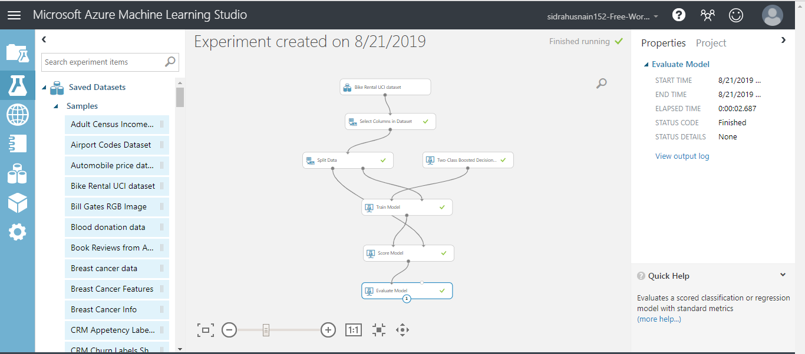

* **Evaluate Model Results:**

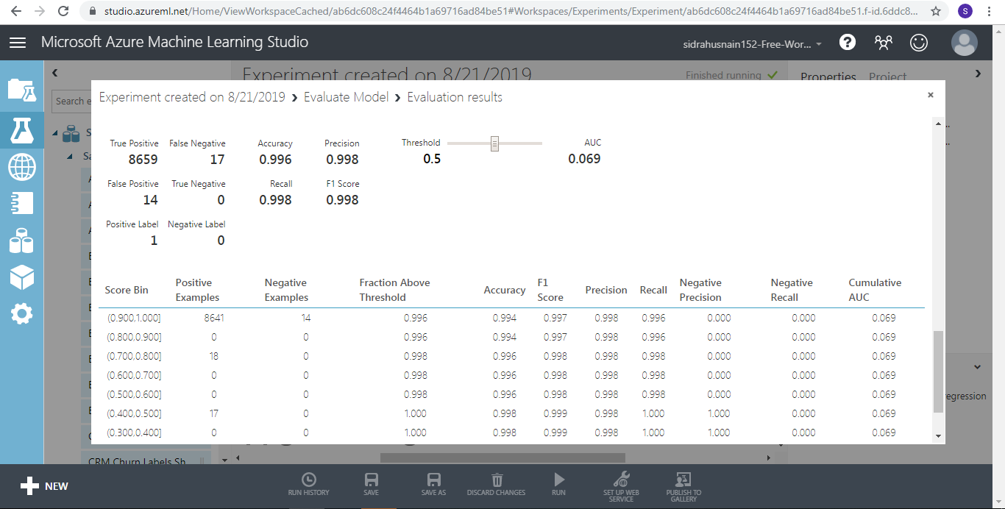

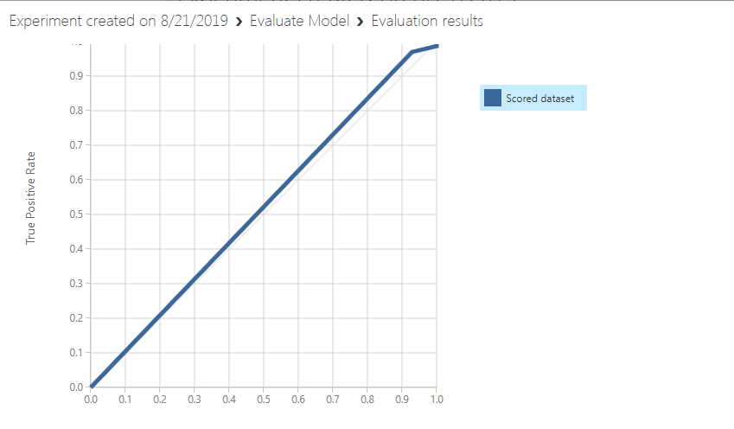

* **Score Model Result:**

